**Assignment -1**

Python Programming

|  |  |
| --- | --- |
| Assignment Date | 12 September 2022 |
| Student Name | Sathya Jayasri S |
| Student Roll Number | 820419104064 |
| Maximum Marks | 2 Marks |

**Question-1:**

# Consider a list (list = []). You can perform the following commands:

1. **insert i e: Insert integer e at position i.**

# print: Print the list.

1. **remove e: Delete the first occurrence of integer e.**

# append e: Insert integer e at the end of the list.

1. **sort: Sort the list.**

# pop: Pop the last element from the list.

1. **reverse: Reverse the list.**

# Initialize your list and read in the value of n followed

**by n lines of commands where each command will be of the 7 types listed above. Iterate through each command in order and perform the corresponding operation on your list.**

|  |
| --- |
| **Solution:** |
| **list=[1,3,1,5,2,4,1]**  **list.insert(5,6)**  **print(‘inserted list’,list)**  **list.remove(1)**  **print(‘removed list’,list)**  **list.append(7)**  **print(‘appended list’,list)**  **list.sort()**  **print(‘sorted list’,list)**  **list.pop()**  **print(‘popped list’,list)**  **list.reverse()**  **print(‘reversed list’,list)** |  |
|  |  |
|  |  |
|  |  |
|  |  |

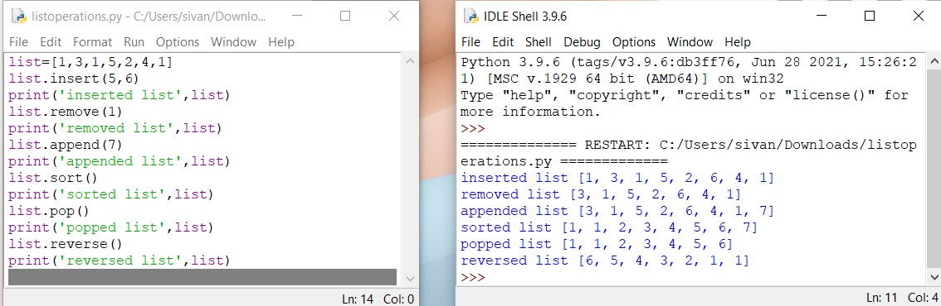

**Question-2:**

# Write a calculator program in python

|  |
| --- |
| **Solution:**  **def add(x,y):**  **return x+y**  **def subtract(x,y):**  **return x-y**  **def multiply(x,y):**  **return x*y**  **def divide(x,y):**  **return x/y**  **print(“Select operation”)**  **print(“1.Add”)**  **print(“2.Subract”)**  **print(“3.Multiply”)**  **print(“4.Divide”)**  **While True:**  **choice = input(“Enter choice(1/2/3/4):”)**  **if choice in ( ‘ 1 ’ , ’ 2 ’ , ’ 3 ’ , ’ 4 ’ ):**  **num1 = float(input(“Enter first number”))**  **num2 = float(input(“Enter second number”))**  **if choice == ‘ 1 ‘ :**  **print(num1 ,’ + ‘ , num2, ‘ = ‘ , add(num1, num2))**  **elif choice == ‘ 2 ‘:**  **print(num1 , ‘ – ‘ , num2, ‘ = ‘ , subtract(num1, num2))**  **elif choice == ‘ 3 ‘ :**  **print(num1 , ‘ * ‘, num2, ‘ = ‘ , multiply(num1, num2))**  **elif choice == ‘ 4 ‘ :**  **print(num1 , ‘ / ‘ , num2, ‘ = ‘,divide(num1, num2))**  **next_calculation = input(“Let’s do next calculation?(yes/no):”)**  **if next_calculation == “ no “:**  **break**  **else:**  **print(“ Invalid Input “)** |
|  |  |
|  |  |
|  |  |
|  |  |
|  |  |
|  |  |
|  |  |
|  |  |

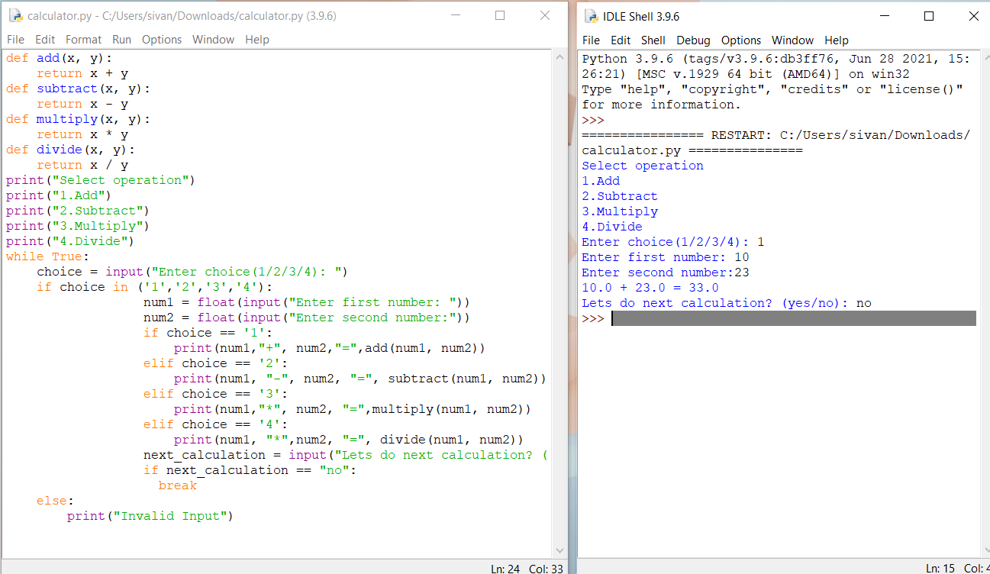

**Question-3:**

# Write a program to concatenate , reverse and slice a string in python

|  |
| --- |
| **Solution:**  **str1 = “Hello”**  **str2 = ”World”**  **print(“String 1:”,str1)**  **print(“String 2:”,str2)**  **str = str1+str2**  **print(“Concatenated two different strings:”,str)**  **reverse_String = “”**  **count = len(str)**  **while count > 0:**  **reverse_String += str[ count – 1 ]**  **count = count – 1**  **print (“The reversed string using a while loop is : ”,reverse_String)**  **sliced_str = slice(6)**  **print(str[sliced_str])** |
|  |  |
|  |  |
|  |  |
|  |  |
|  |  |
|  |  |
|  |  |
|  |  |

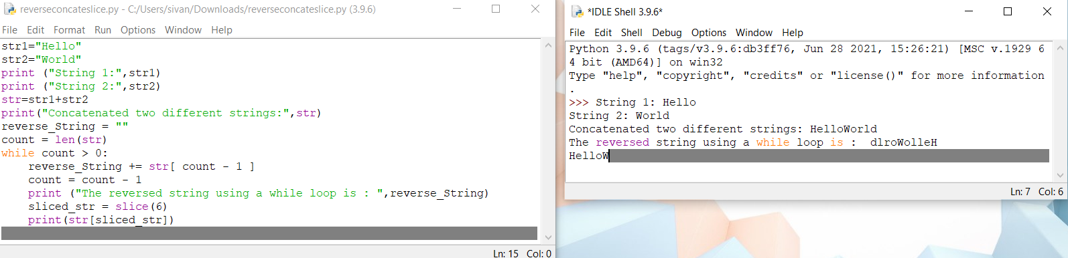

**Question-4:**

# Why python is popular programming language

Python has a simple syntax and in form of natural english language which helps lot of people to get a hold of what is coding in their first experience.it is highly flexible,reliable and fast to code.

**Question-5:**

# What are the other frameworks that can be used with python?

Bottle,Flask,Django,Web2py,AIOHTTP,CherryPy,Dash Falcon

**Question-6:**

# Full Form of WSGI

# WSGI stands for Web Server Gateway Interface

# 